Big mountain ski resort recently installed a chair lift . This chair lift is design to help increase distribution of visitors across the mountain. The new chair lift comes with additional operating costs. The operating cost for this season is about $1.5 million. Consequently they chose to investigate their valuing procedure to decide whether their estimating system of charging a superior over the typical cost of resorts in its market fragment was the best approach. With an end goal to make up for the extra working expense of the seat lift the business needed to decide the amount they would increment ticket costs or would they be compelled to diminish features.
Accordingly the business proposed four scenarios that they feel would approve the ticket cost. The situations incorporate the permanent closure of up to 10 of the most un-utilized runs and keeping the cost structure something very similar. Increment ticket costs to take care of the extra working expense or increment the cost and add extra features. The extra features being assessed are increasing the vertical drop by adding a run to a point 150 feet beneath the ongoing longest path including the implementation of an extra seat lift to bring skiers back up. Increment the upward drop as above yet incorporate two acres of land of snow making. Ultimately increment the longest run to 0.2 mile to boast a run 3.5 miles long, which would require extra snow making inclusion of 4 acres of land.
The model comprising of shutting down least utilized runs versus change in ticket cost to compensate for the extra working expense was examined and the examination beneath (figure 1). The examination shows that you
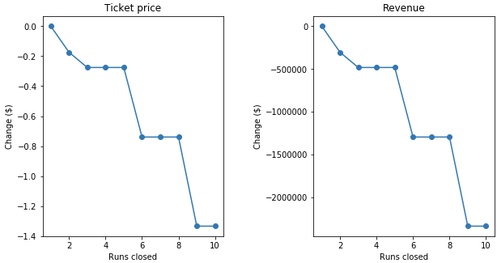
Figure 1 Analysis of closing runs vs revenue
can quit for the day 5 runs without massive change in ticket cost with an overall drop of about $500,000 in income, any further drop of runs would bring about much lower ticket costs and practically 3x loss of income.
The models for expanding cost and adding highlights were examined and expanding the vertical drop by 150 feet would uphold a cost increment of $8.67 and would build the income to around $15 million. Taking a gander at a similar model however adding snow making over 2 acres of land would uphold a cost increment of $10.59 per ticket and would create an extra $3.5 million in income for a sum of $18.5 million. The last model of expanding the longest shown to 0.2 miles and ensuring snow inclusion by the expansion of 4 acres of land of snow making gave no difference for pricing tickets.
With the expansion in income for situation including expanding the upward drop by 150ft it would seem to be the legitimate decision for thought as the situations for shutting down runs and adding to the longest run bring less (shutting down runs) or no change (expanding longest run) in income. Although the adding snow making to the expanded vertical drop would increment income by $3.5 million bucks over a similar choice with no extra snow making this choice likewise would require extra working expenses for snow making and is the additional expense for snow making approve the $2 cost ticket increment. Further examination ought to be performed with additional information, for example, cost for snow making, the optics of a $8.67 increment versus a $10.59 increment and the accessibility to move individuals on the additional snow region.

